Aishwarya B
192321059
Lab Program 12,13
CSA1616 DATA WAREHOUSING AND DATA MINING

EXPERIMENT-12
1.Covariance and correlation Children of three ages are asked to indicate their preference for three photographs of adults. Do the data suggest that there is a significant relationship between age and photograph preference? What is wrong with this study? Photograph: Age of child A B C 5-6 years: 18 22 20 7-8 years: 2 28 40 9-10 years: 20 10 40 1. Use cov() to calculate the sample covariance between B and C. 2. Use another call to cov() to calculate the sample covariance matrix for the preferences. 3. Use cor() to calculate the sample correlation between B and C. 4. Use another call to cor() to calculate the sample correlation matrix for the preference.

Aim:- To show the .Covariance and correlation Children of three ages are asked to indicate their preference for three photographs of adults.

Algorithm :-

- Take the values of B and C.
- Find the mean of B and the mean of C.
- Subtract the mean from each value (get deviations).
- Multiply the deviations of B and C for each pair.
- Add all products.
- Divide by n – 1 → this gives the sample covariance.

Code:-

# Preference data for photographs A, B, C

A <- c(18, 2, 20)

B <- c(22, 28, 10)

C <- c(20, 40, 40)

# 1. Sample covariance between B and C cov(B, C)
# 2. Sample covariance matrix for A, B, C prefs <- data.frame(A, B, C)
cov(prefs)

# 3. Sample correlation between B and C

cor(B, C)

# 4. Sample correlation matrix for A, B, C cor(prefs)
output:-

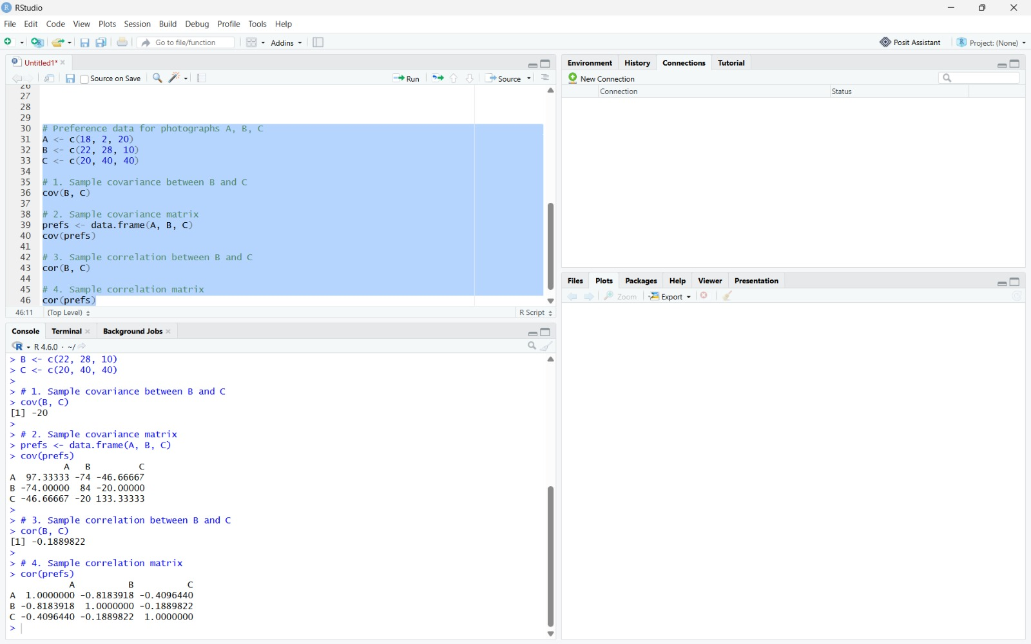
Result:- It is executed successfully.

Experiment-13
- Imagine that you have selected data from the All Electronics data warehouse for analysis. The data set will be huge! The following data are a list of All Electronics prices for commonly sold items (rounded to the nearest dollar). The numbers have been sorted: 1, 1, 5, 5, 5, 5, 5, 8, 8, 10, 10, 10, 10, 12, 14, 14, 14, 15, 15, 15, 15, 15, 15, 18, 18, 18, 18, 18, 18, 18,
18, 20, 20, 20, 20, 20, 20, 20, 21, 21, 21, 21, 25, 25, 25, 25, 25, 28, 28, 30, 30, 30. (i)
Partition the dataset using an equal-frequency partitioning method with bin equal to 3 (ii) Apply data smoothing using bin means and bin boundary. (iii) Plot Histogram for the above frequency division

Aim:- To divide the given price data into equal-frequency bins, apply data smoothing (bin means & bin boundaries), and draw a histogram using R.

Algorithm :-

Equal-frequency partitioning
  - Read the sorted data.
  - Decide number of bins = 3.
  - Count total items.
  - Compute items per bin = total / 3.
  - Divide the data into 3 bins with equal number of values

Data smoothing

Bin Mean

  - For each bin, calculate the mean.
  - Replace every value in the bin with the bin’s mean.

Bin Boundary

  - For each bin, find the minimum and maximum value.
  - Replace each value with the nearest boundary (min or max)

Histogram
  - Read the price data.
  - Use the hist() function to plot a histogram.
  - Label the axes.

Code:-# Data
price <- c(1,1,5,5,5,5,5,8,8,10,10,10,10,12,14,14,14,

15,15,15,15,15,15,18,18,18,18,18,18,18,18,

20,20,20,20,20,20,20,21,21,21,21,25,25,25,

25,25,28,28,30,30,30)

# (i) Equal-frequency partitioning (3 bins) n <- length(price)
bin_size <- n / 3

bins <- split(price, ceiling(seq_along(price)/bin_size)) bins
# (ii) Smoothing # A. Bin Mean
bin_means <- lapply(bins, function(b) rep(mean(b), length(b))) bin_means
# B. Bin Boundary

bin_boundary <- lapply(bins, function(b){ lower <- min(b)
upper <- max(b) sapply(b, function(x)
if(abs(x-lower) < abs(x-upper)) lower else upper)
})

bin_boundary

# (iii) Histogram

hist(price, main="Price Histogram", xlab="Price", ylab="Frequency")
output:-

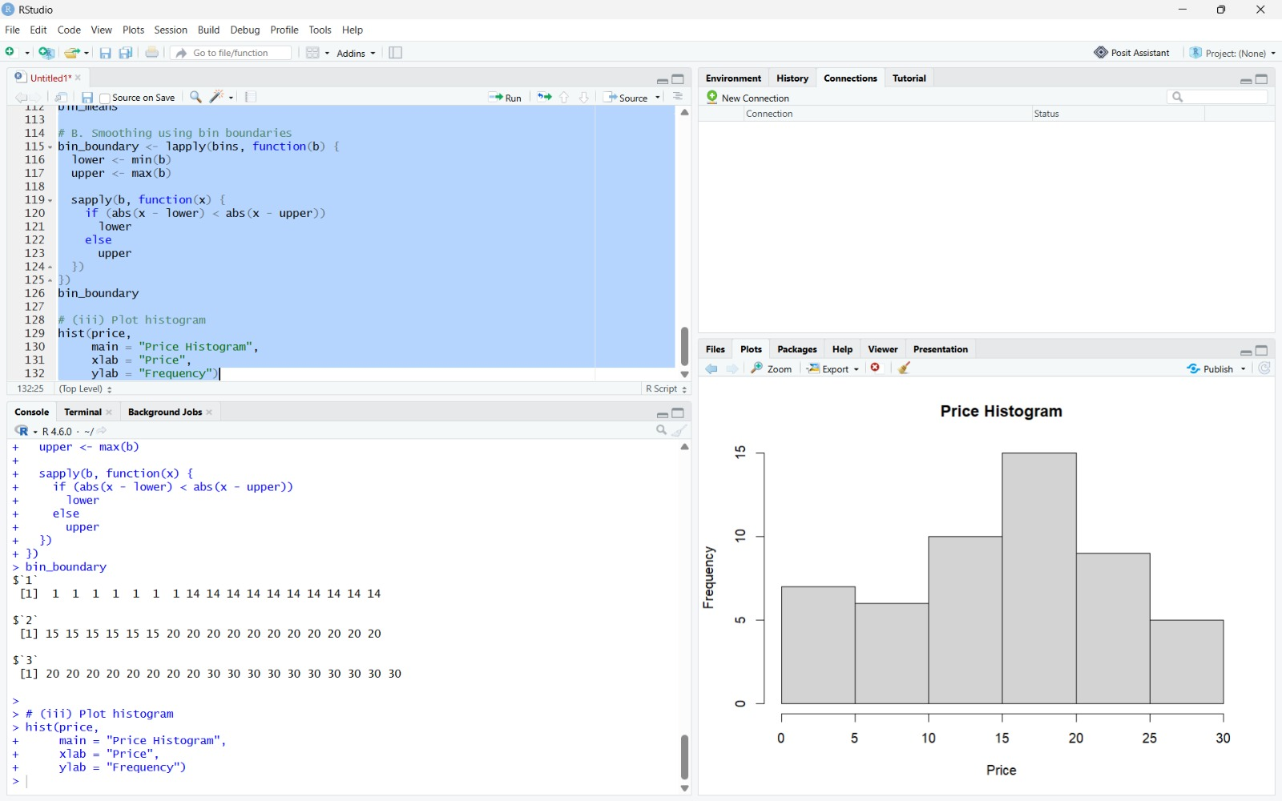

Result:- It is executed successfully.

